**Kitchenmaster | 11 Comber Road | Carryduff | Belfast | BT8 8AN Email:** [**sales@kitchenmaster-ni.com**](mailto:sales@kitchenmaster-ni.com) **Web:** [**www.kitchenmaster-ni.com**](http://www.kitchenmaster-ni.com)

**Head Office:** 028 9081 4777

**PRODUCT GUIDANCE SHEET**

RELOAD NO.5

# CONCENTRATED ALL PURPOSER CLEANER DISINFECTANT

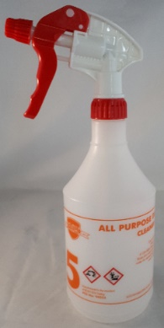

A pleasantly perfumed and extremely powerful bactericidal hard surface cleaner that quickly penetrates and removes grime and soap scum safely from all washable surfaces. Independently tested to BS EN 1276 standard for biocidal efficacy at a dilution of 40:1 and a contact time of 5 minutes. To aid product recognition the Reload No.5 product label, the solutions, both concentrated and diluted, and the label on the trigger bottle are orange.

Product Name: Reload No.5

Description: Concentrated perfume surface cleaner sanitiser (BS EN 1276 approved)

Pack Size: 4x2Lt

Pallet Size: 84

Product Code: REAQUABLUE-4X2L

Product Name: Reload No.5 750ml Bottles

Description: Reload No 1 Screen Printed Spray Bottles

Pack Size: Individual

Product Code: PAK-TRI-RELOAD5

# HOW TO USE

Suitable for a wide variety of cleaning operations in housekeeping and building services applications as a damp wipe surface cleaner and sanitiser. For use on all hard surfaces including showers, baths, sinks, taps and fittings, and also tables and walls.

## Clean-As-You-Go Hygiene

Remove gross debris. Spray directly onto the surface or equipment. Depending on the degree of soiling allow sufficient time for the product to penetrate the soil. Agitate heavily soiled areas if necessary, then simply wipe away with a clean cloth or absorbent paper to leave a fresh clean surface.

**Issue Date: May 2021**

**Kitchenmaster products are manufactured under ISO 9001 & registered Quality Management System**.

Reload No.5 must be diluted before use using an Kitchenmaster bottle fill dispenser. For a cleaning and disinfecting solution dilute with one plunge of dispenser per orange labelled Reload No.5 spray bottle and fill with water or via an automatic chemical/water mixing station.

**Bottle Fill Instruction – Manual or Water Fed Dosing Units:**

1. Unscrew trigger spray from bottle and fill with water or indeed water & chemical from the water fed unit to the top fill mark on the bottle.
2. Insert bottle neck on to the dispensing nozzle and push upwards – priming the unit.
3. Position spray bottle on the base of the drip tray to allow vending to commence.
4. PULL lever towards you in an upward direction until it CLICKS or push the round button. This is now ready to vend.
5. To vend product PUSH lever downwards. The concentrate will be dispensed into the bottle at the correct dilution to water. For water fed units depress the button until the bottle is filled with chemical and water.
6. Remove the bottle from the base and screw trigger spray onto the bottle. Turn bottle upside down to ensure thorough mixing has occurred.

**Test Certificate can be found in our Technical Area**

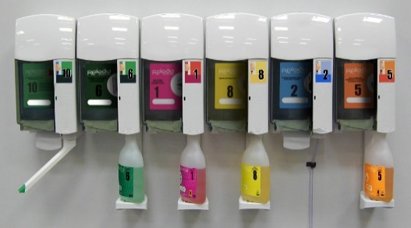

# SAFETY ADVICE

Danger Causes severe skin burns and eye damage. Toxic to aquatic life with long lasting effects~~.~~ Do not breathe mist or spray. Wear protective gloves, protective clothing and eye/face protection. IF SWALLOWED: Rinse mouth. Do NOT induce vomiting. IF ON SKIN (or hair): Remove/Take off immediately all contaminated clothing. Rinse skin with water/ shower. IF IN EYES: Rinse cautiously with water for several minutes. Remove contact lenses, if present and easy to do. Continue rinsing. Immediately call a POISON CENTRE or doctor/physician.

**For detailed advice on safe handling and storage of the concentrated product refer to the product Safety Data Sheet.**

FOR INDUSTRIAL & INSTITUTIONAL USE ONLY. Keep out of reach of children.

Note: Diluted solutions are not classified as hazardous



***COSHH STATEMENT***

COSHH is a law that requires all employers to take steps to control substances (chemicals) that may cause harm to employees, contractors, and visitors to the workplace. Every work environment will be different in terms of the hazardous chemicals that are present, and how these are used, and individual assessments may be necessary to consider how chemicals can be handled and stored safely, in addition to ensuring that appropriate PPE and training is provided for employees. Product MSDS and Product Guidance Sheets are intended to help when carrying out a COSHH assessment, however if further advice is needed with regard to specific issues in your work environment, we are happy to provide advice**. E-Mail Technical:** [sales@kitchenmaster-ni.com](mailto:sales@kitchenmaster-ni.com)