**Kitchenmaster | 11 Comber Road | Carryduff | Belfast | BT8 8AN Email:** [**sales@kitchenmaster-ni.com**](mailto:sales@kitchenmaster-ni.com) **Web:** [**www.kitchenmaster-ni.com**](http://www.kitchenmaster-ni.com)

**Head Office:** 028 9081 4777

**PRODUCT GUIDANCE SHEET**

RELOAD No.6

# CONCENTRATED GLASS & STAINLESS-STEEL CLEANER

A highly effective glass and stainless-steel cleaner for use all glass and stainless-steel fixtures and fittings in the bathroom, kitchen and bedroom. Contains specialised detergents and alcohol to remove grease and finger marks and cleans without smearing. To aid product recognition the Reload No.6 product label, the solutions, both concentrated and diluted, and the label on the trigger bottle are green.

Product Name: Reload No.6

Description: Concentrated glass and stainless-steel cleaner

Pack Size: 4x2Lt

Pallet Size:  84

Product Code: REAQUAGLASS-4X2LT

Product Name: Reload No6 750ML Bottle.

Description: Reload No6 Screen Printed Spray Bottles Pack Size: Each

Product Code: PAK-TRI-RELOAD6

# HOW TO USE

Ideal for hotels, restaurants, building services cleaning and leisure facilities and is highly effective on mirrors, glass, small windows, TV screens and stainless-steel surfaces. Using the atomiser trigger bottle, direct and spray from approximately 30 cm to allow a fine mist to land on the surface. Wipe off using a clean dry cloth or disposable paper. Do not over spray the product as this will cause extra work without any additional benefits and can lead to smears, as glass/metal surfaces are not absorbent. Do not spray product directly onto a TV screen or monitor; switch off the equipment and spray a small amount on to a soft cloth and wipe over the screen.

Reload No6 must be diluted before use. Prepare a cleaning solution with one plunge of dispenser per blue labelled Reload No.6 spray bottle and fill with water or prepare via an automatic chemical/water mixing station.

**Issue Date: May2021**

**Kitchenmaster products are manufactured under ISO 9001 & registered Quality Management System**.

## **Bottle Fill Instruction – Manual or Water Fed Dosing Units:**

1. Unscrew trigger spray from bottle and fill with water or indeed water & chemical from the water fed unit to the top fill mark on the bottle.
2. Insert bottle neck on to the dispensing nozzle and push upwards – priming the unit.
3. Position spray bottle on the base of the drip tray to allow vending to commence.
4. PULL lever towards you in an upward direction until it CLICKS or push the round button. This is now ready to vend.
5. To vend product PUSH lever downwards. The concentrate will be dispensed into the bottle at the correct dilution to water. For water fed units depress the button until the bottle is filled with chemical and water.
6. Remove the bottle from the base and screw trigger spray onto the bottle. Turn bottle upside down to ensure thorough mixing has occurred.

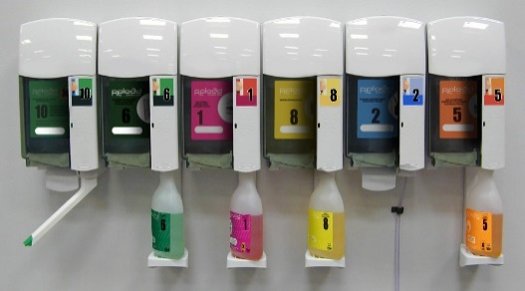

# SAFETY ADVICE

Danger. Causes serious eye irritation. Highly flammable liquid and vapour. Keep away from heat/sparks/open flames/hot surfaces - No Smoking. Wear protective gloves, ~~a~~nd eye/face protection. IF IN EYES: Rinse cautiously with water for several minutes. Remove contact lenses, ifpresent and easy to do. Continue rinsing. If eye irritation persists, get medical advice / attention.

**For detailed advice on safe handling and storage of the concentrated product refer to the product Safety Data Sheet.**

Keep out of reach of children. FOR INDUSTRIAL & INSTITUTIONAL USE ONLY.

Note: Diluted solutions are not classified as hazardous



***COSHH STATEMENT***

COSHH is a law that requires all employers to take steps to control substances (chemicals) that may cause harm to employees, contractors, and visitors to the workplace. Every work environment will be different in terms of the hazardous chemicals that are present, and how these are used, and individual assessments may be necessary to consider how chemicals can be handled and stored safely, in addition to ensuring that appropriate PPE and training is provided for employees. Product MSDS and Product Guidance Sheets are intended to help when carrying out a COSHH assessment, however if further advice is needed with regard to specific issues in your work environment, we are happy to provide advice**. E-Mail Technical:** [sales@kitchenmaster-ni.com](mailto:sales@kitchenmaster-ni.com)