**Kitchenmaster | 11 Comber Road | Carryduff | Belfast | BT8 8AN Email:** [**sales@kitchenmaster-ni.com**](mailto:sales@kitchenmaster-ni.com) **Web:** [**www.kitchenmaster-ni.com**](http://www.kitchenmaster-ni.com)

**Head Office:** 028 9081 4777

**PRODUCT GUIDANCE SHEET**

RELOAD No.8

# Graphical user interface Description automatically generatedCONCENTRATED ROOM FRAGRANCE

# 

An extremely effective air odour neutraliser, which combines a long-lasting lemon perfume with a unique encapsulating agent to completely neutralise stale odours. To aid product recognition the Reload No.8 product label, the solutions, both concentrated and diluted, and the label on the trigger bottle are yellow.

Product Name: Reload No.8

Description: Concentrated Room Fragrance

Pack Size: 4x2Lt

Pallet Quantity: 84

Product Code: REAQUAAIR-4X2LT

Product Name: Reload No.8 750ml Bottles.

Description: Reload No.8 screen printed spray bottles Pack Size: Individual

Product Code: PAK-TRI-RELOAD8

# HOW TO USE

Suitable for use in all housekeeping, building services and residential care/lodging sectors to treat malodours. Using the trigger bottle atomiser spray, direct and spray Reload No.8 upwards into the corners of the room and allow a few moments to disperse. Due to the strong residual fragrance do not overuse; this should be the final product used on vacating the room after all other cleaning operations have been completed. It is safe to use on curtains, carpets, and other soft furnishings.

Reload No.8 must be diluted before use using an Kitchenmaster bottle fill dispenser. Dilute by adding one plunge of dispenser per yellow screen printed Reload No.8 spray bottle and fill with water or prepare solution using an automatic chemical/water mixing station.

**Issue Date: May 2021**

**Kitchenmaster products are manufactured under ISO 9001 & registered Quality Management System**.

## **Bottle Fill Instruction – Manual or Water Fed Dosing Units:**

1. Unscrew trigger spray from bottle and fill with water or indeed water & chemical from the water fed unit to the top fill mark on the bottle.
2. Insert bottle neck on to the dispensing nozzle and push upwards – priming the unit.
3. Position spray bottle on the base of the drip tray to allow vending to commence.
4. PULL lever towards you in an upward direction until it CLICKS or push the round button. This is now ready to vend.
5. To vend product PUSH lever downwards. The concentrate will be dispensed into the bottle at the correct dilution to water. For water fed units depress the button until the bottle is filled with chemical and water.
6. Remove the bottle from the base and screw trigger spray onto the bottle. Turn bottle upside down to ensure thorough mixing has occurred.

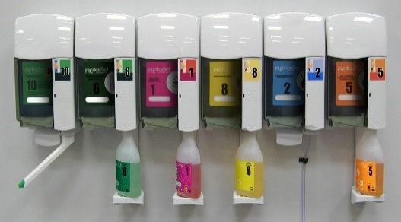

# SAFETY ADVICE

Danger. Highly flammable liquid and vapour. Causes serious eye irritation. Harmful to aquatic life with long lasting effects. Keep away from heat/sparks/open flames/hot surfaces - No Smoking. Wear protective gloves~~,~~ and eye/face protection. IF IN EYES: Rinse cautiously with water for several minutes. Remove contact lenses, ifpresent and easy to do. Continue rinsing. If eye irritation persists, get medical advice / attention.

**For detailed advice on safe handling and storage of the concentrated product refer to the product Safety Data Sheet.**

FOR INDUSTRIAL & INSTITUTIONAL USE ONLY. Keep out of reach of children.

Note: Diluted solutions are not classified as hazardous



***COSHH STATEMENT***

COSHH is a law that requires all employers to take steps to control substances (chemicals) that may cause harm to employees, contractors, and visitors to the workplace. Every work environment will be different in terms of the hazardous chemicals that are present, and how these are used, and individual assessments may be necessary to consider how chemicals can be handled and stored safely, in addition to ensuring that appropriate PPE and training is provided for employees. Product MSDS and Product Guidance Sheets are intended to help when carrying out a COSHH assessment, however if further advice is needed with regard to specific issues in your work environment, we are happy to provide advice**. E-Mail Technical:** [sales@kitchenmaster-ni.com](mailto:sales@kitchenmaster-ni.com)