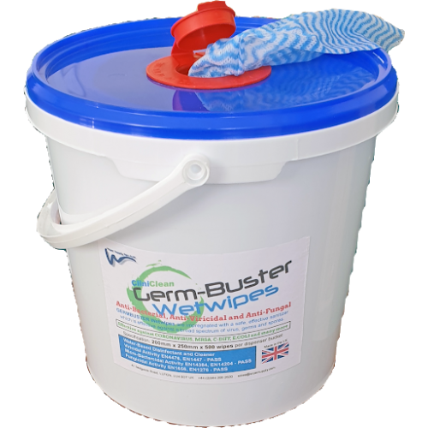

**GERMBUSTER WIPES (500 PER TUB)**

**ANTI VIRAL**

**ANTI BACTERIAL**

**ANTI FUNGAL.**

**SUITABLE FOR USE IN SCHOOLS, HOSPITALS, CARE HOMES,**

**FOOD HYGIENE, HOSPITALITY, HOUSKEEPING AND MORE.**

**SAFE ON HANDS**

**CERTIFICATIONS; EN1276, EN1650, EN14476.**

**PCS NUMBER 99523.**