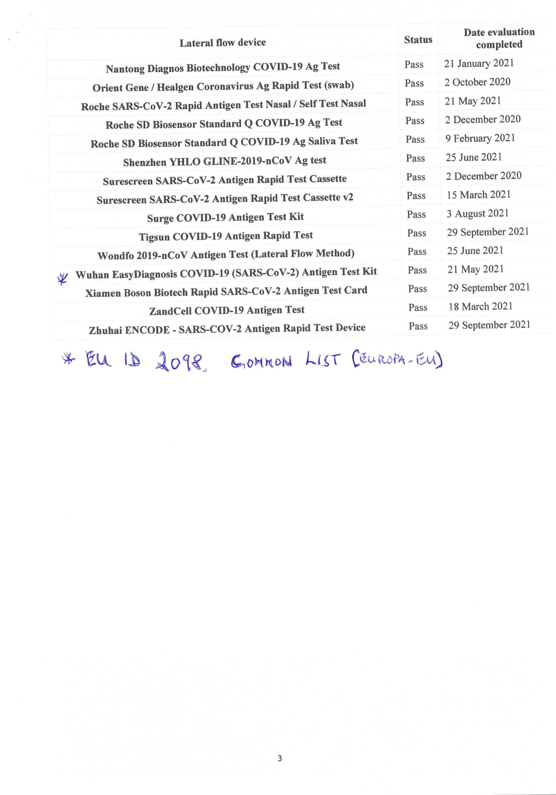

**EU ID 2098 for covid-19 rat common-list en.pdf(europa.eu)**