HYGIENE AND INFECTION CONTROL

HOW AND WHERE TO USE THE BLUE MICROFIBRE CLOTH.
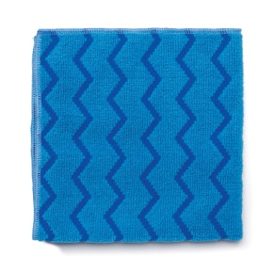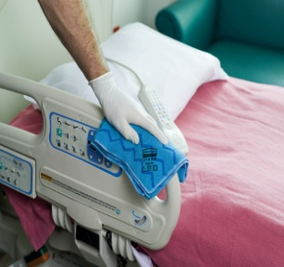

Requirements.
1. Gloves. 2. Blue Microfibre Cloth. 3. Water. 4. Detergent solution.
Procedure.
Use a fresh cloth for every room. Use dry for cleaning wooden surfaces. Dampen cloth with water or detergent solution for cleaning other hard surfaces. Use cloth folded flat in quarters (as in picture) and when the surface becomes dirty , refold cloth to expose a clean surface . This will provide 8 surfaces for cleaning. Do not bunch the cloth when cleaning. Use a different colour coded cloth for cleaning the bathroom. When finished place cloth in bag for washing.

Parkside Ireland Limited. Ph; 01-6268342, Fax; 01-6266689, email; parkside@parksideirl.com

