Parksideecohygiene.

All your needs in Hygiene for the Food, Hospitality, Care facilities, Retail and Commercial. CONTACT US PHONE 01-6268342 ; EMAIL; parkside@parksideirl.com

ECO PRODUCTS
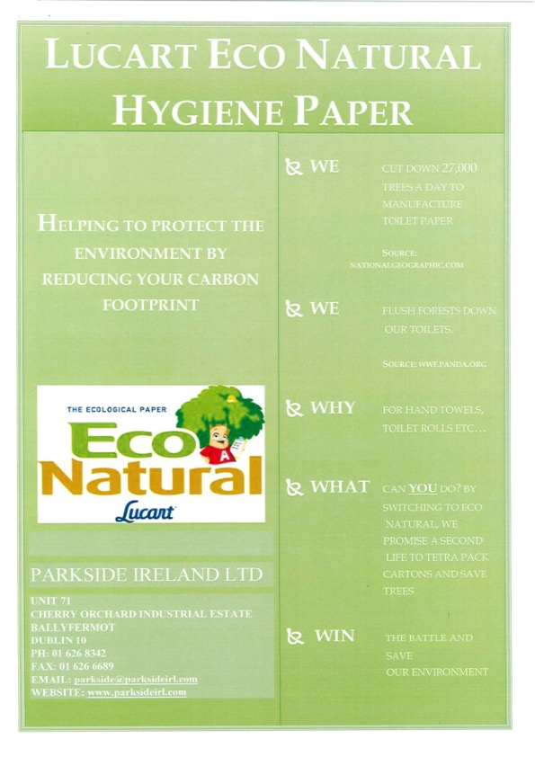
Click HERE for more details about Paper and other products

Paper

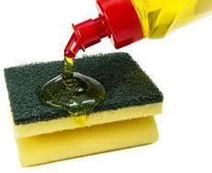
Click HERE for more details about Cleaning Chemicals and other products

Chemicals, Cleaning Agents.
Click HERE for more details about Sanitisers and other products
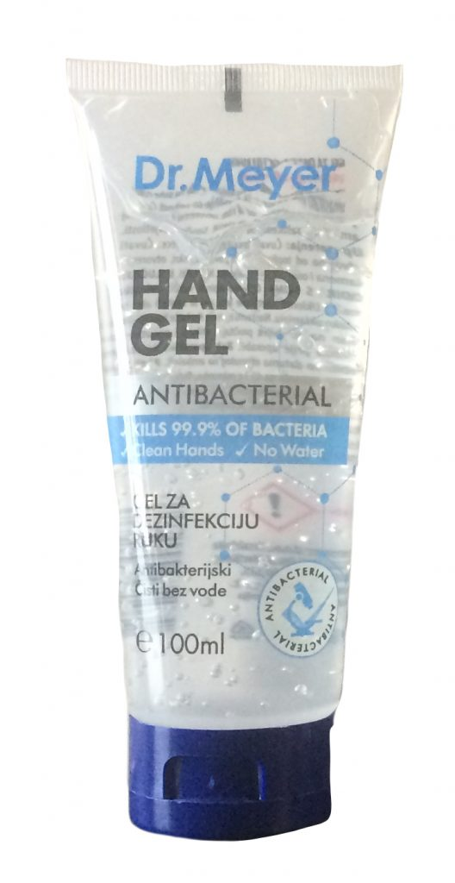

Sanitisers, Hand Hygiene

