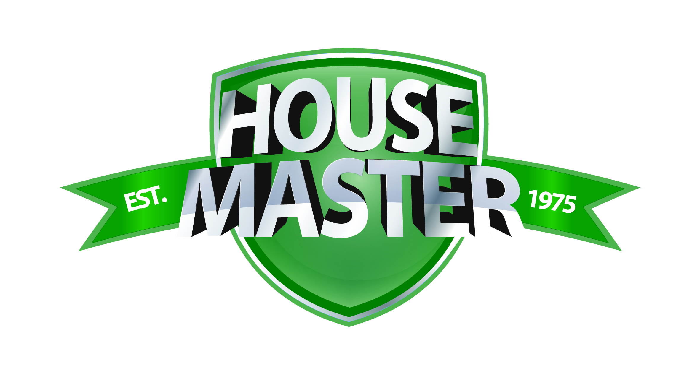
11 Comber Road, Carryduff, BELFAST, BT8 8AN
Tel: 028 9081 4777 Fax: 028 9081 2881
Website: www.kitchenmaster-ni.com Email: sales@kitchenmaster-ni.com

TECHNICAL SPECIFICATION

SHINE ON STAINLESS STEEL POLISH

SHINE ON: A specialist metal polish containing mineral oils to leave stainless steel surfaces with a bright finish. Ideal for use on lift doors, handrails, kick plates and a superb finishing product for all stainless steel surfaces in commercial catering and building services cleaning applications

Features include:
- Suitable for use on steel surfaces in commercial kitchens.
- Leaves surfaces with a bright and glossy finish.
- Packaged in handy ready-to-use trigger spray.
- Non-aerosol formulation – ozone friendly.
- All surfactants used are biodegradable and phosphate free.

PROPERTIES: SPECIFICATION:
Appearance @ 20ºC White, milky liquid
pH (neat) 6.0 +/-0.5
Odour Characteristic
Specific Gravity @ 20ºC 0.960+/- 0.005
Flammability Non-flammable

DIRECTIONS FOR USE:
- SHINE ON is used directly from the bottle as a ready to go solution and requires no dilution with water.
- Direct and lightly spray from approximately 30 cm from the surface to be polished.
- Spray and wipe over the surface using a clean dry cloth or disposable paper and then leave to air dry for final gloss
- finish.
- It is not a cleaner, so ensure the surface is cleaned prior to use and is completely dry before applying.

STORAGE:
Store in original container and protect from extremes of temperature. Do not store in direct sunlight nor allow the product to freeze. Shelf life (in unopened original container) is a minimum of 18 months.

SAFETY ADVICE:
Under the new GHS Standard this product is not classified. Please refer to section 2.2 of the Safety Data Sheet for more information.

PACK SIZES:
- 6x750ml per case (144 per pallet) Order Code: HMSHINEON-6X750ML

